

Member Dashboard Manual
  - A practical guide to signing in, finding member resources, communicating, and keeping your account secure

Open the live member portal

BEFORE YOU BEGIN

Get ready to sign in
You need a verified member account, your UG staff email, your password, and a reliable internet connection.
- Use a current browser such as Chrome, Edge, Safari, or Firefox.
- Use a private device where possible. Avoid saving your password on shared computers.
- If the secretariat issued a temporary Staff-ID password, replace it with a personal password after first sign-in.

STEP 1

Open the UG UTAG website

Figure 1. The public UG UTAG homepage. Select Member login at the top-right.
Go to the UG UTAG website, then select Member login. The secure sign-in page opens.

STEP 2

Sign in securely
The sign-in page contains only two required fields.
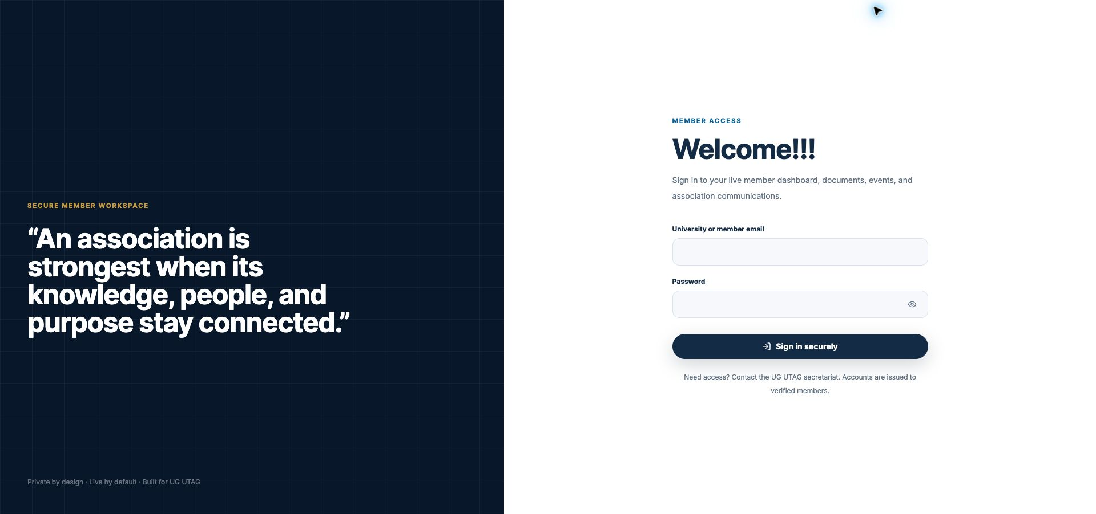
Figure 2. The member sign-in page with the email, password, Show password, and Sign in securely controls.
- Enter your UG staff email exactly as it appears in your member record.
- Enter your password. Select the eye icon only when it is safe to reveal the characters on screen.
- Select Sign in securely.
FIRST SIGN-IN If you are prompted to replace a temporary password, follow the on-screen instructions.

STEP 3

Understand the Overview
After a successful sign-in, the portal opens the member workspace.
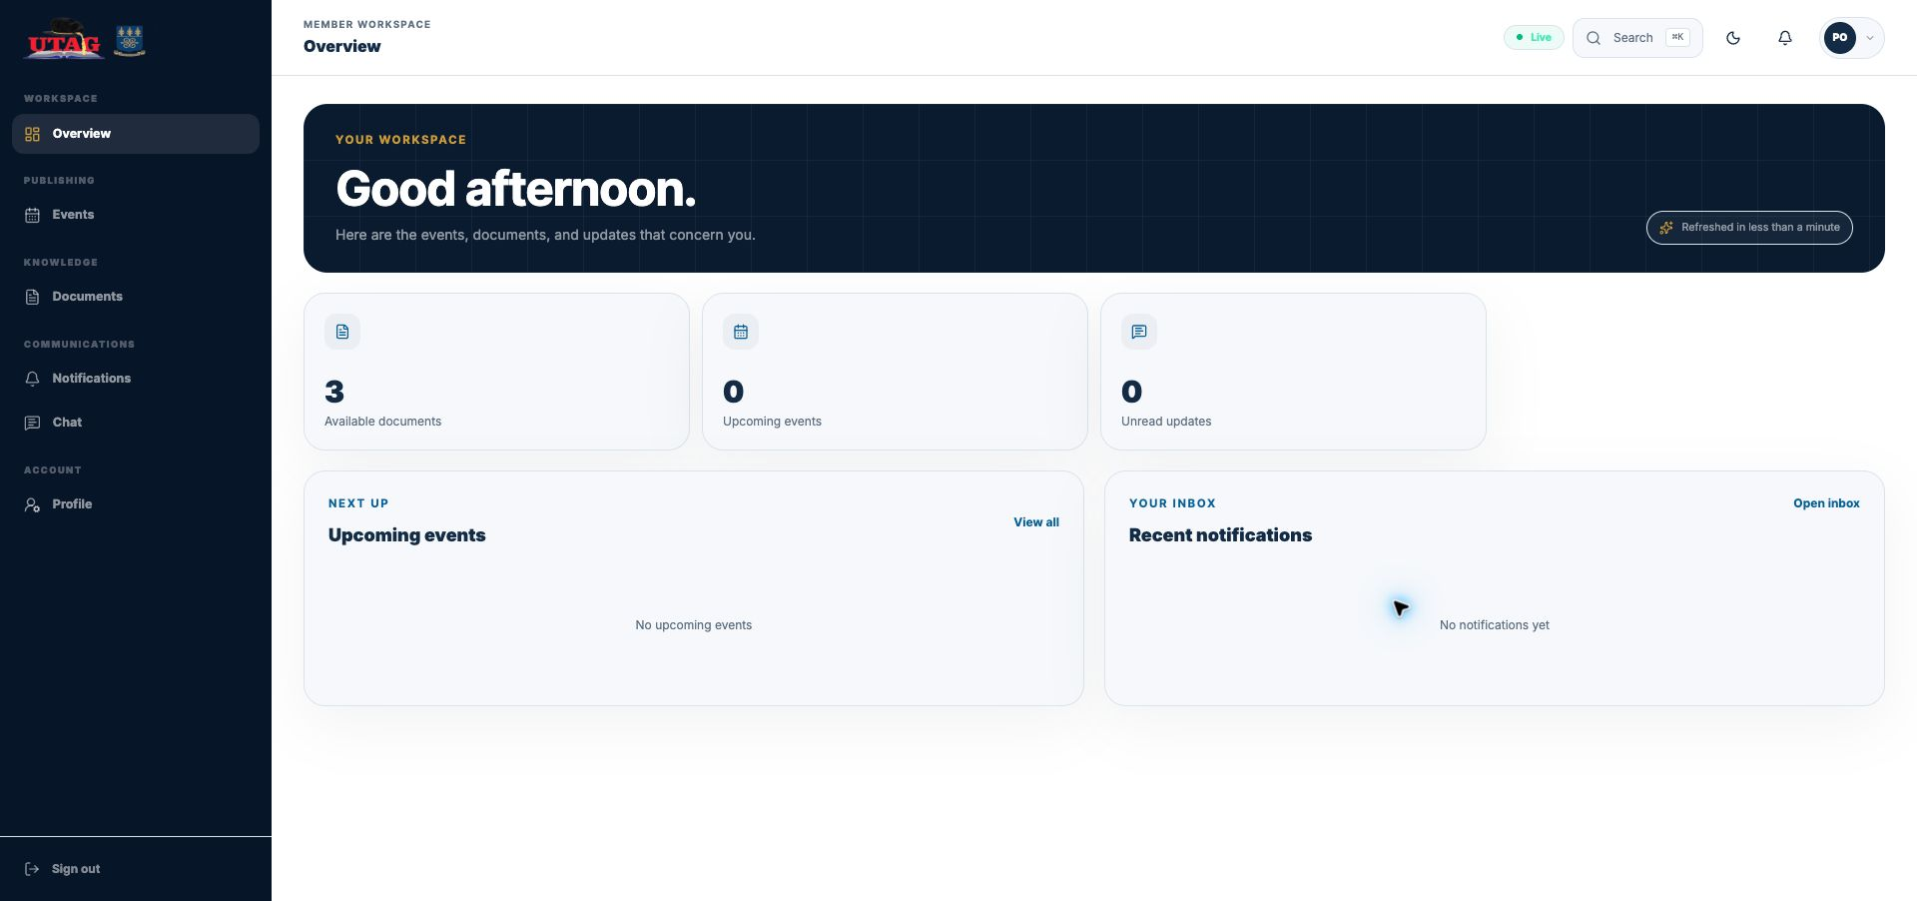
Figure 3. Overview shows summary cards, upcoming events, recent notifications, and the primary navigation.
- Summary cards show the number of available documents, upcoming events, and unread updates.
- View all opens the full Events page; Open inbox opens Notifications.
- The Live indicator confirms that the workspace is connected for current updates.
AREA | WHAT MEMBERS USE IT FOR
Overview | At-a-glance totals, upcoming events, and recent notifications.
Events | Browse schedules, filter by status, and open event details.
Documents | Find protected records, view details, and preview available files.
Notifications | Read official announcements, direct alerts, and system activity.
Chat | Use approved direct and group conversations.
Profile | Maintain account details, campus affiliation, photo, and password.

STEP 4

Find an event
Open Events from the left sidebar. Search, filter, sort, or refresh the list, then open a record for details.
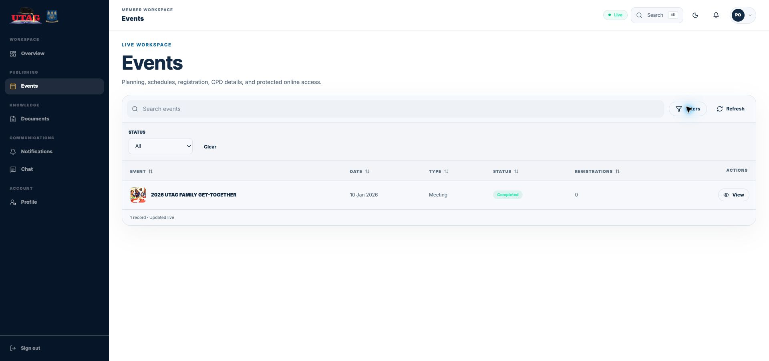
Figure 4. Events with Filters open. Choose a Status or select Clear to reset the filter.
- Use Search events to find a title or related text.
- Select Filters, choose a Status, or select Clear to return to all records.
- Select a column heading to sort. Select Refresh to request the latest list.
- Select View on the event row to open its detail panel.
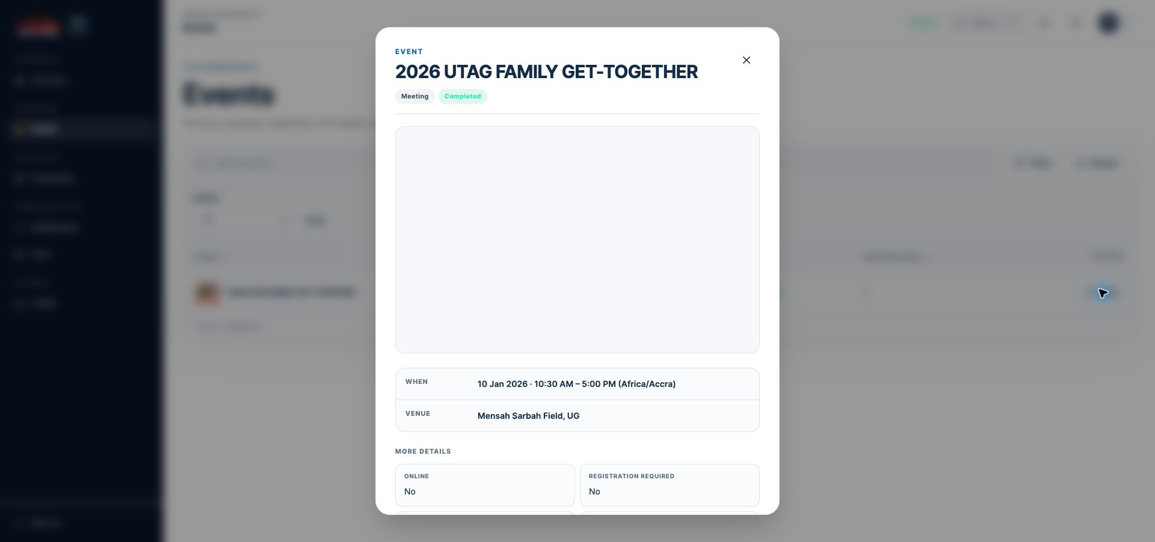
Figure 5. An event detail panel shows the date, time, venue, status, and registration information.

STEP 5

Find a document
Open Documents from the left sidebar. The list displays the document reference, title, category, publication status, date, version, and available actions.
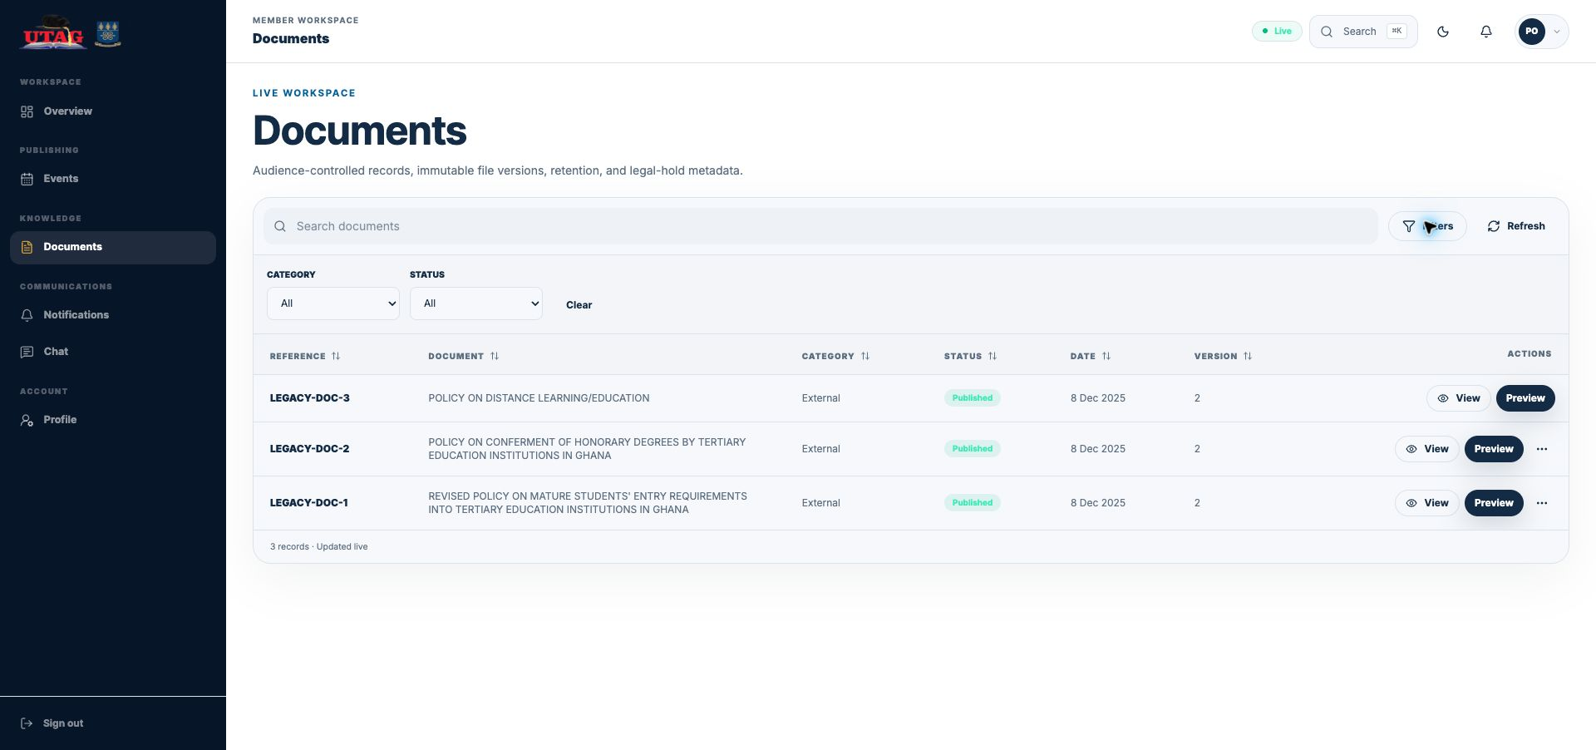
Figure 6. Documents with Category and Status filters open.
- Use Search documents to find a reference or title.
- Select Filters to choose a Category or Status; select Clear to remove the filters.
- Select View for metadata and document details. Select Preview to open the protected preview workspace.
- A three-dot More actions menu may appear when extra actions are available for that record.
DOCUMENT CONTROLS

View details and preview a file
The two actions serve different purposes: View shows record metadata; Preview opens the protected reading area.
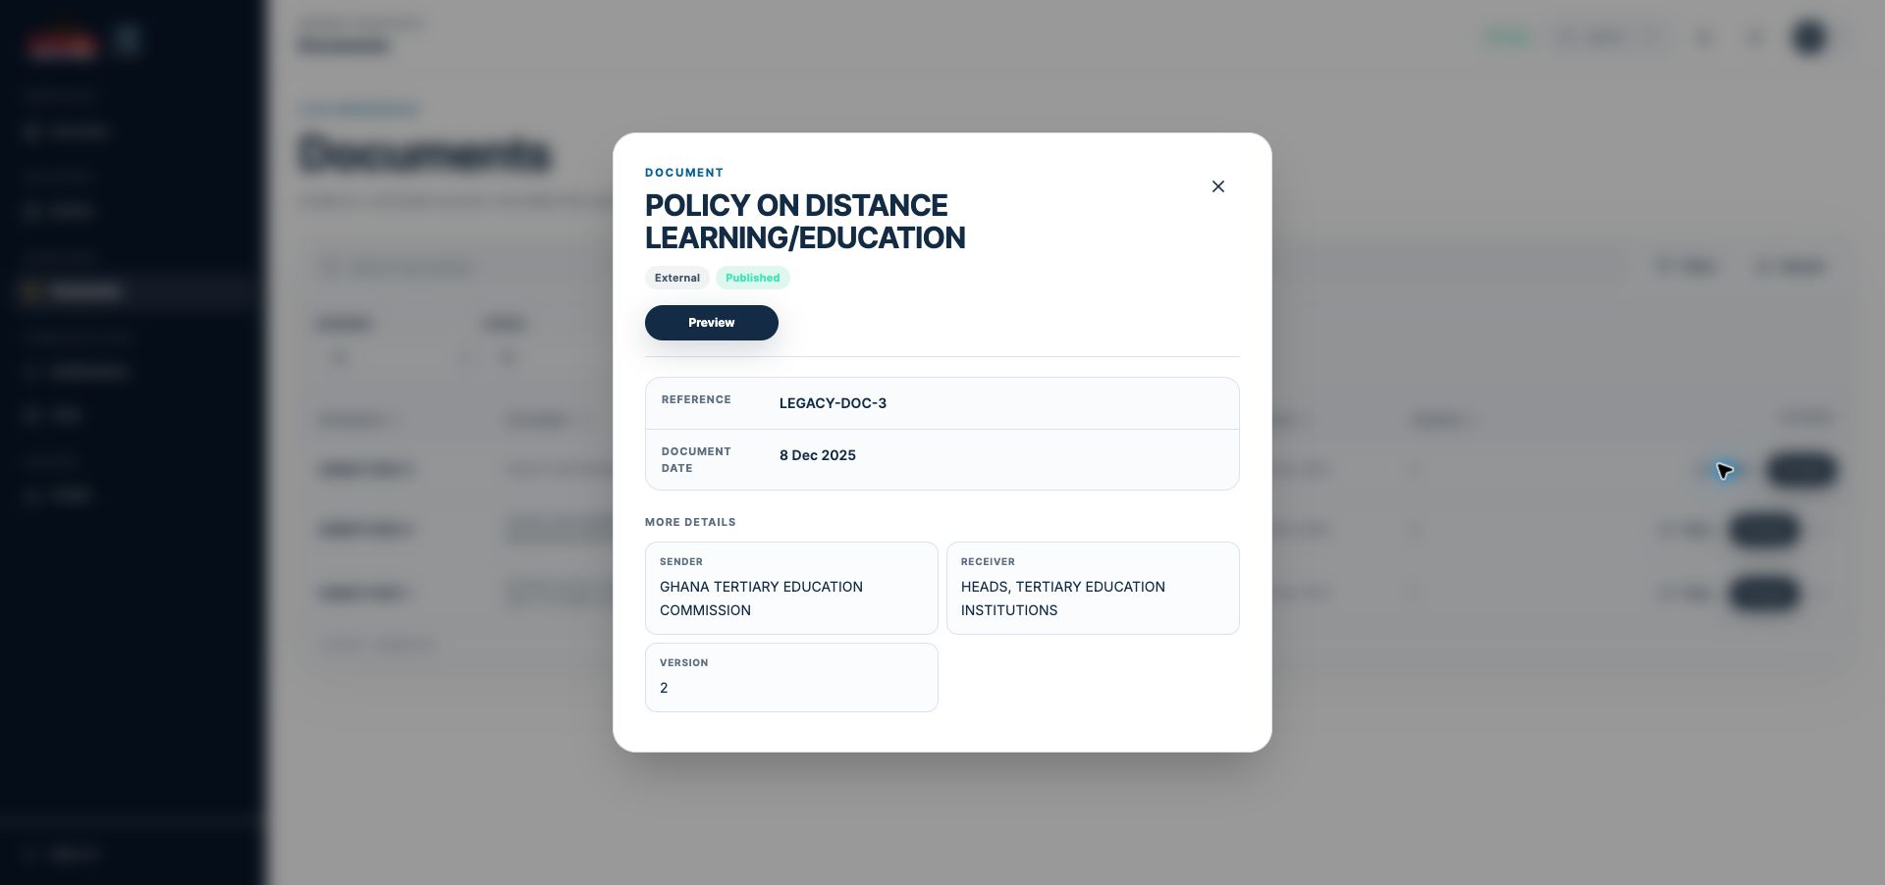
Figure 7. View opens the document detail panel with reference, date, sender, receiver, version, and a Preview button.
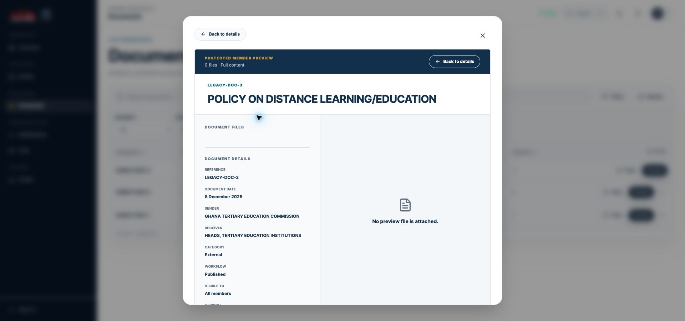
Figure 8. Preview opens the protected document viewer. Some records may show No preview file is attached.
- Use Back to details to return to the metadata panel.
- Use the X close control to return to the document list.
- If no preview file is attached, the record can still contain useful reference and workflow information.

STEP 6

Read notifications
Notifications is your personal inbox for official announcements, direct alerts, and system activity.
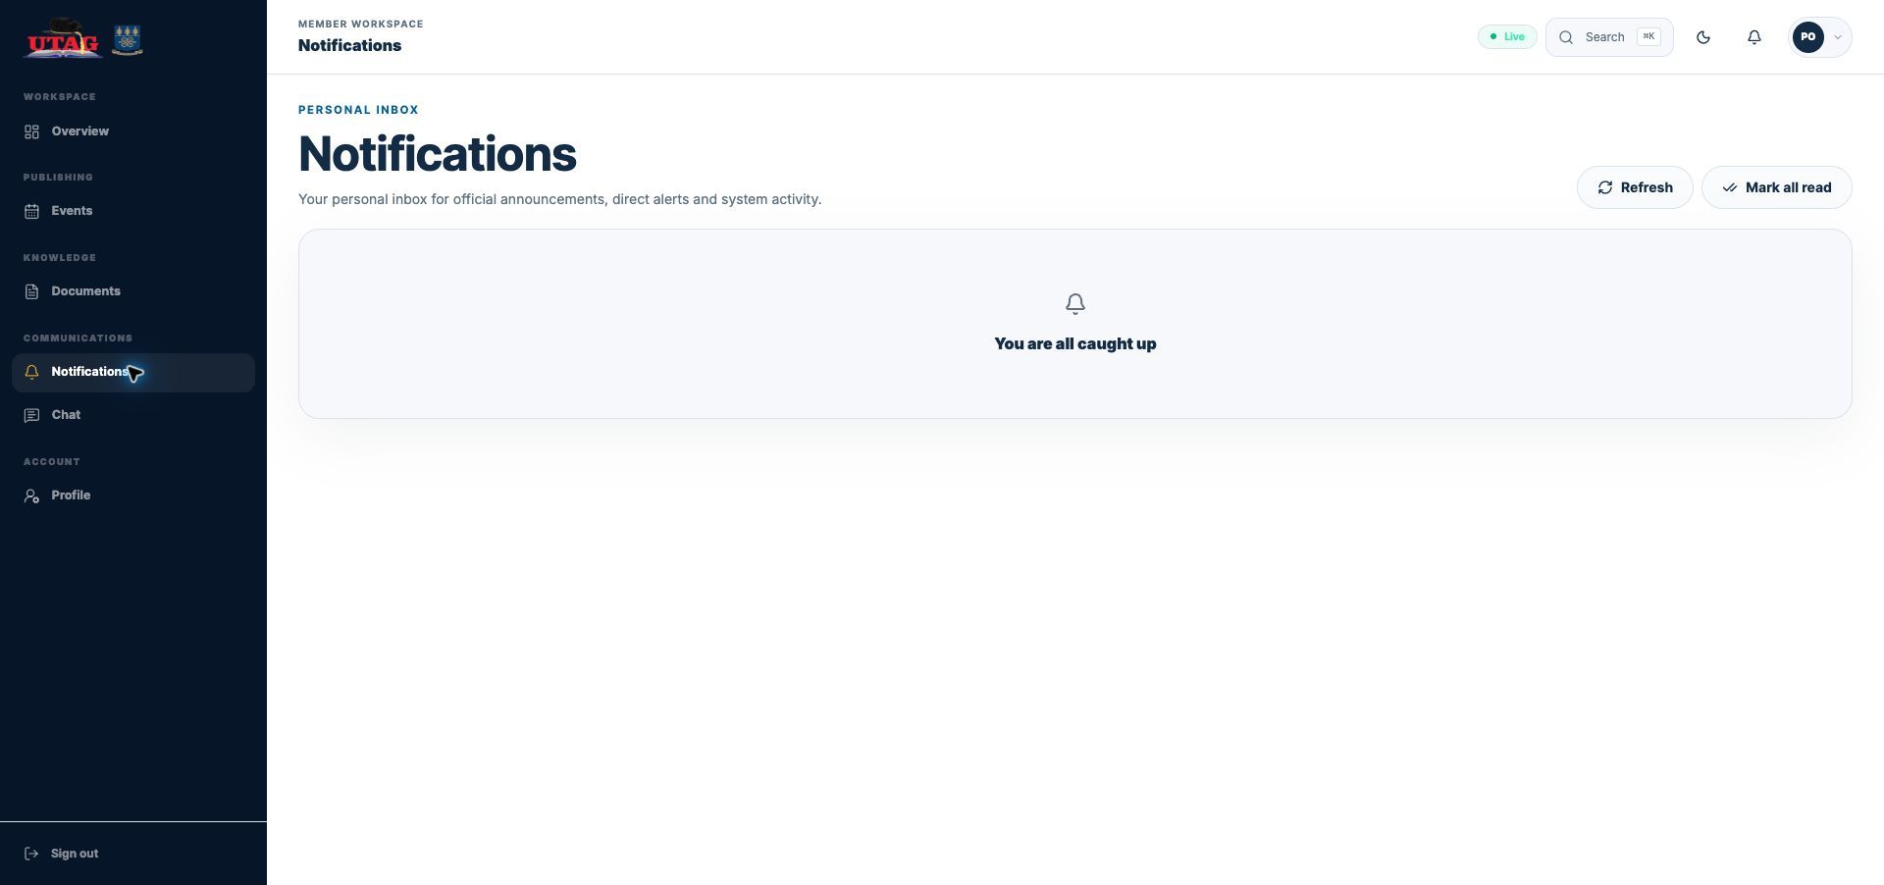
Figure 9. The Notifications inbox. Refresh requests the latest items; Mark all read clears the unread status.
- Select Notifications in the left sidebar to open the full inbox.
- Select Refresh to request the latest items.
- Select Mark all read only when you are ready to clear all unread indicators.
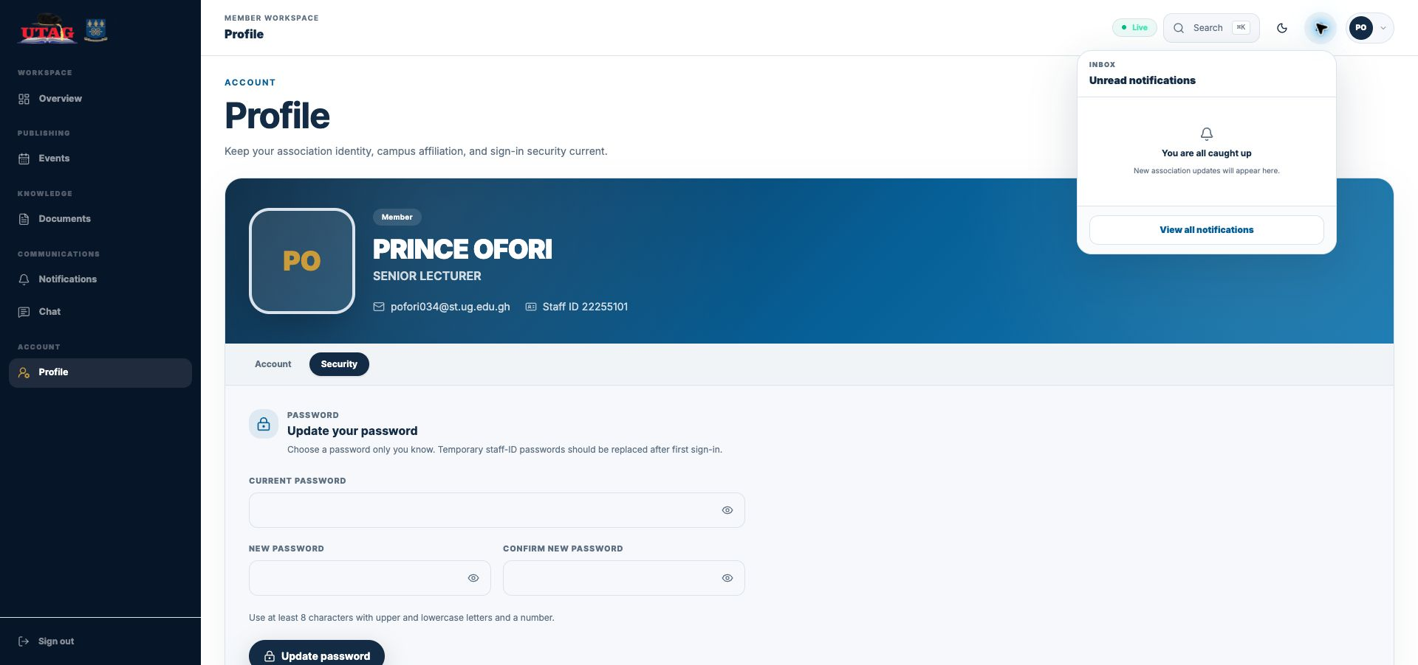
Figure 10. The bell in the top bar opens a compact unread-notification menu and a View all notifications link.

STEP 7

Use member chat
Chat supports approved direct and group conversations in the member workspace.
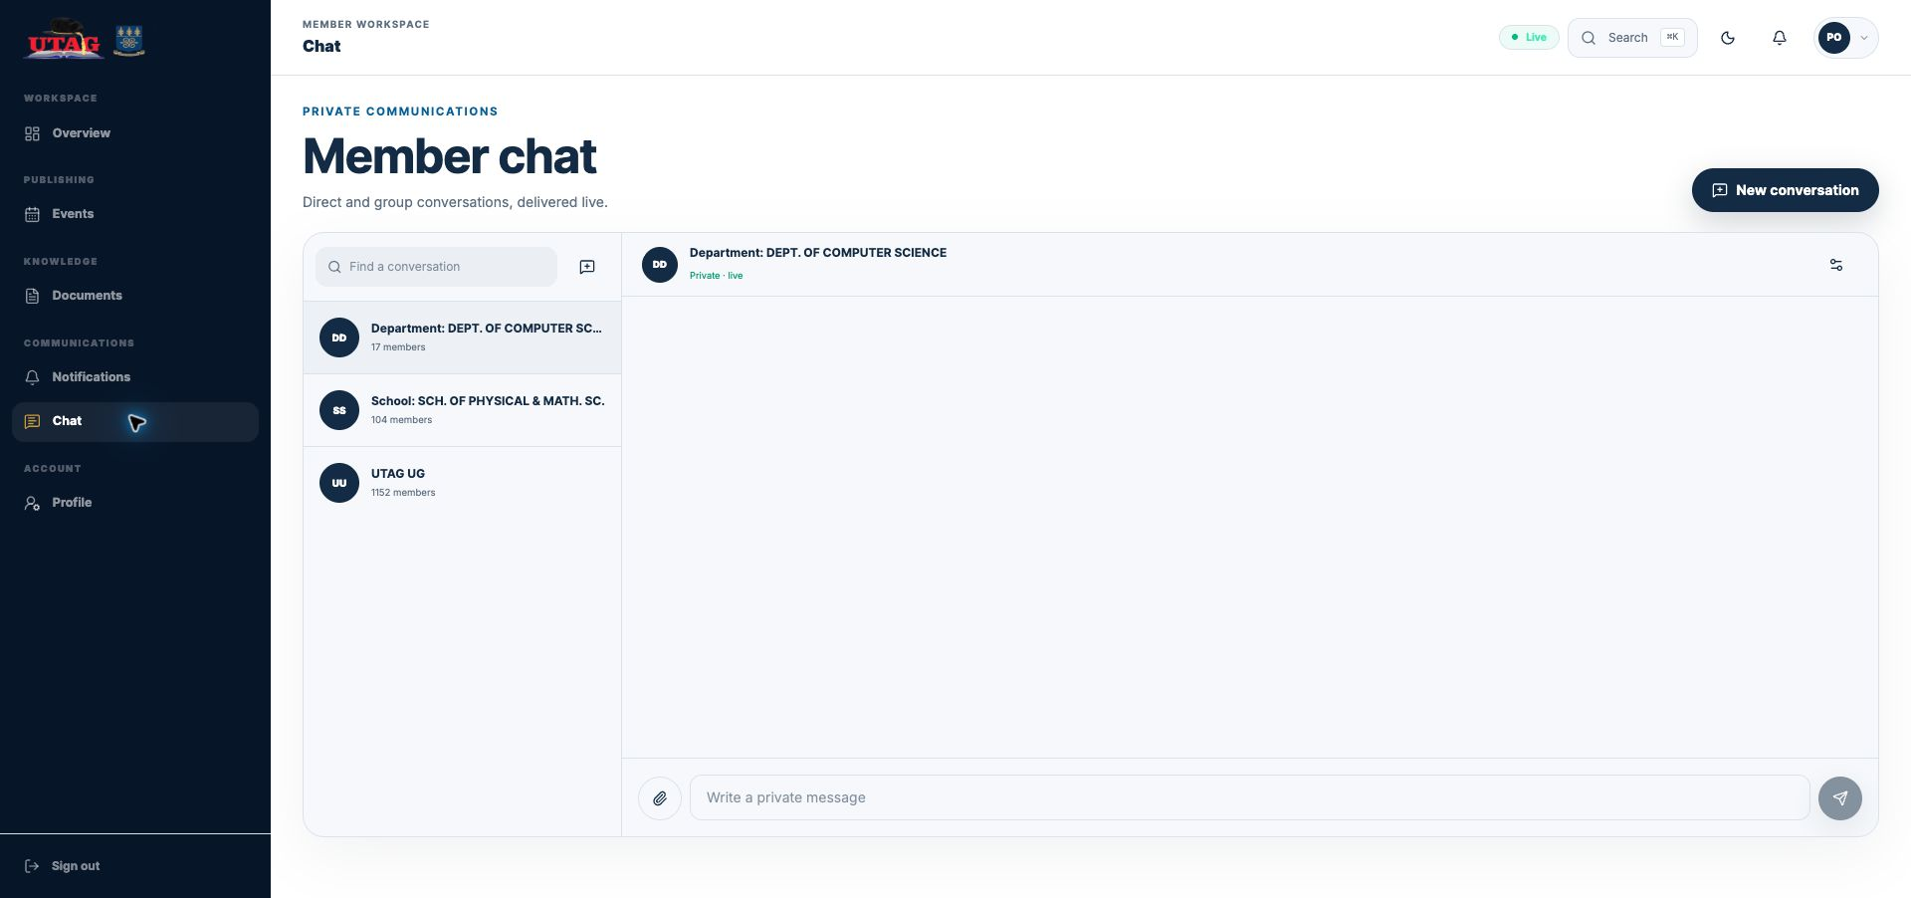
Figure 11. Member chat with conversation search, group list, message field, attachment control, and Send button.
- Select a conversation from the list, or use Find a conversation.
- Select New conversation to start an available direct or group conversation.
- Write a private message, optionally attach an appropriate file, then select Send.
- The Group settings control displays group information and membership. Some controls depend on your role.

STEP 8

Update your profile
Open Profile in the left sidebar. The Account tab keeps your association identity, contact details, portrait, and campus affiliation current.
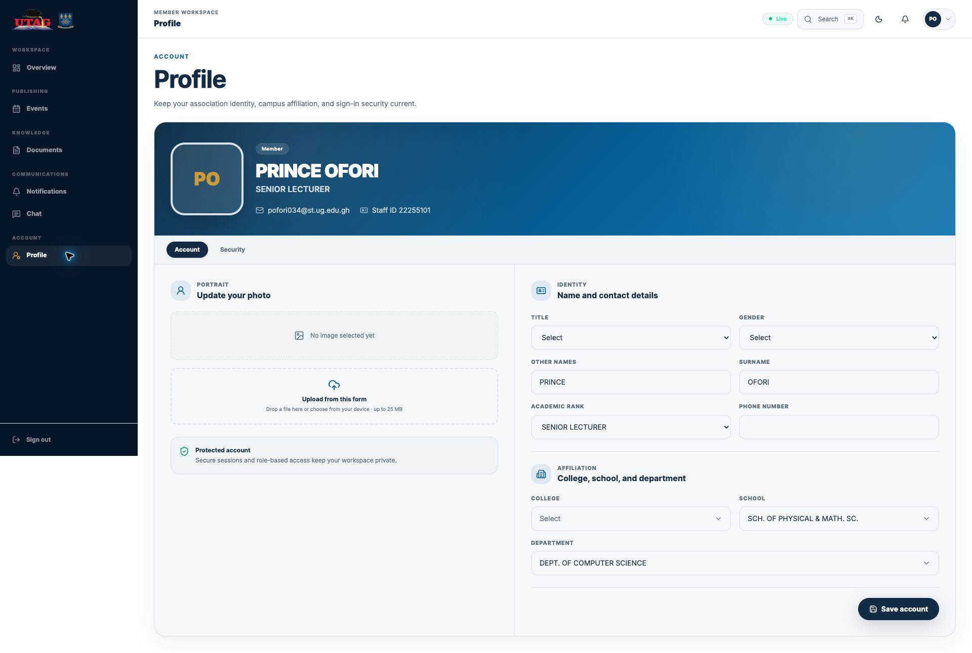
Figure 12. Profile → Account contains the photo, identity, academic rank, phone, and affiliation controls.
- Review your displayed name, academic rank, email, and Staff ID.
- Update the editable fields and choose a profile image if required.
- Confirm the college, school, and department selections.
- Select Save account to apply the changes.

STEP 9

Change your password
In Profile, select the Security tab.
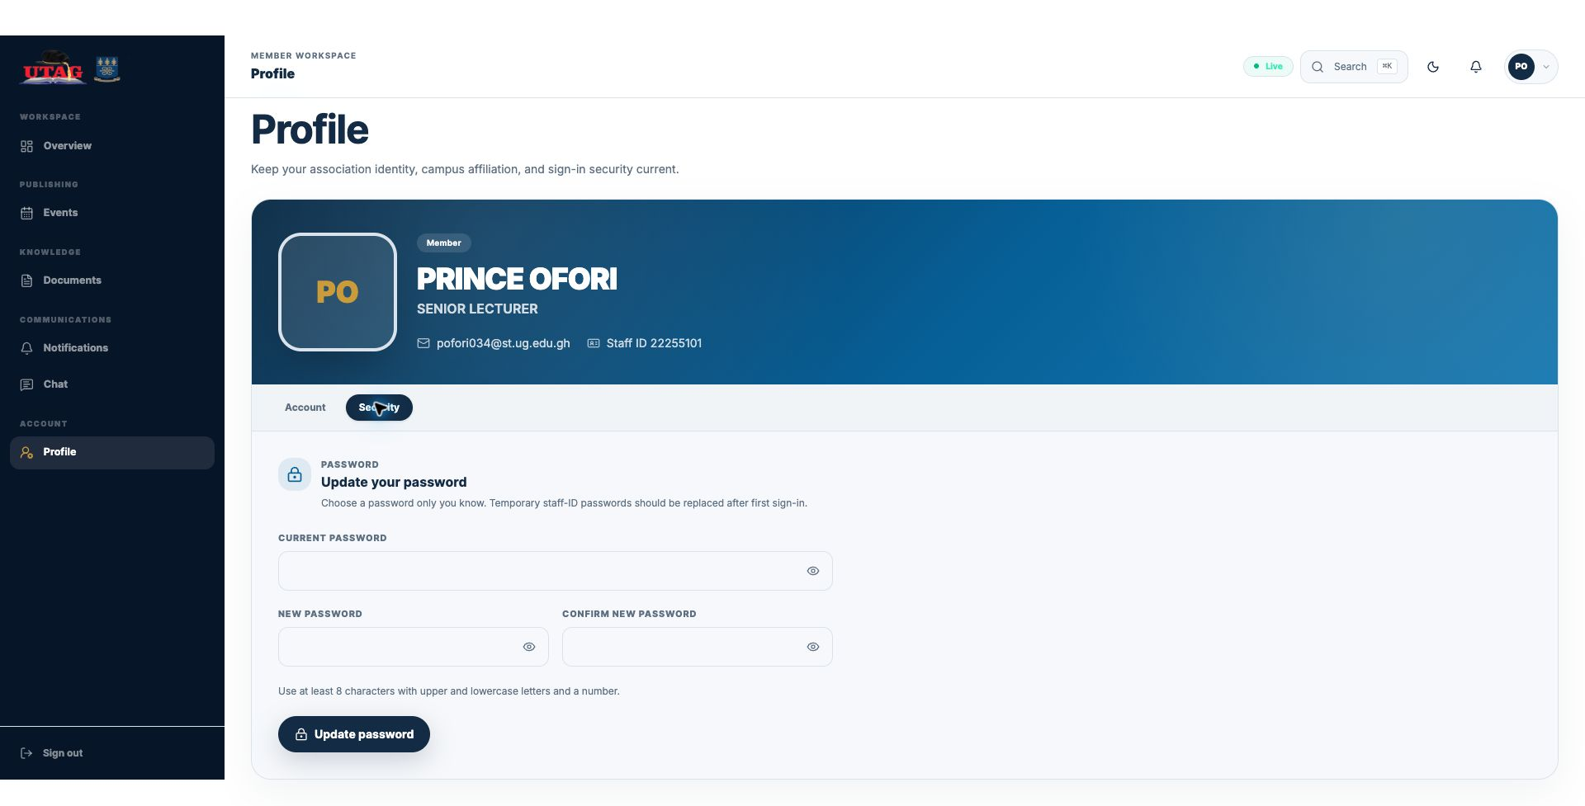
Figure 13. Profile → Security contains Current password, New password, Confirm new password, and Update password.
- Enter your Current password.
- Enter a New password using at least 8 characters with uppercase and lowercase letters and a number.
- Enter the same value in Confirm new password.
- Select Update password. Use the new password the next time you sign in.
PASSWORD PRACTICE Use a unique password that you do not use for another service. Do not include your Staff ID, name, or easily guessed dates.

QUICK TOOLS

Search the workspace and sign out
The top bar provides fast navigation, theme control, notifications, and access to your profile.
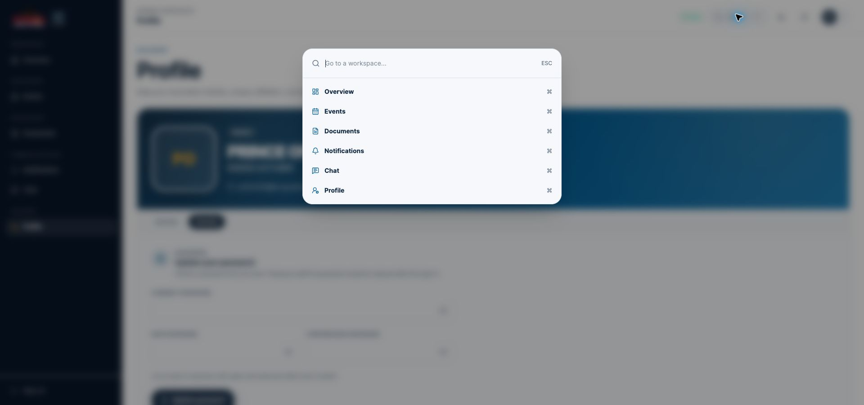
Figure 14. Select Search (or use the displayed keyboard shortcut) to jump to a workspace section.
- Search filters the list of workspace sections as you type.
- The moon/sun control changes the visual theme; it does not change your data.
- Select your initials to open Profile.
- Select Sign out at the bottom of the sidebar when you finish, especially on a shared device.
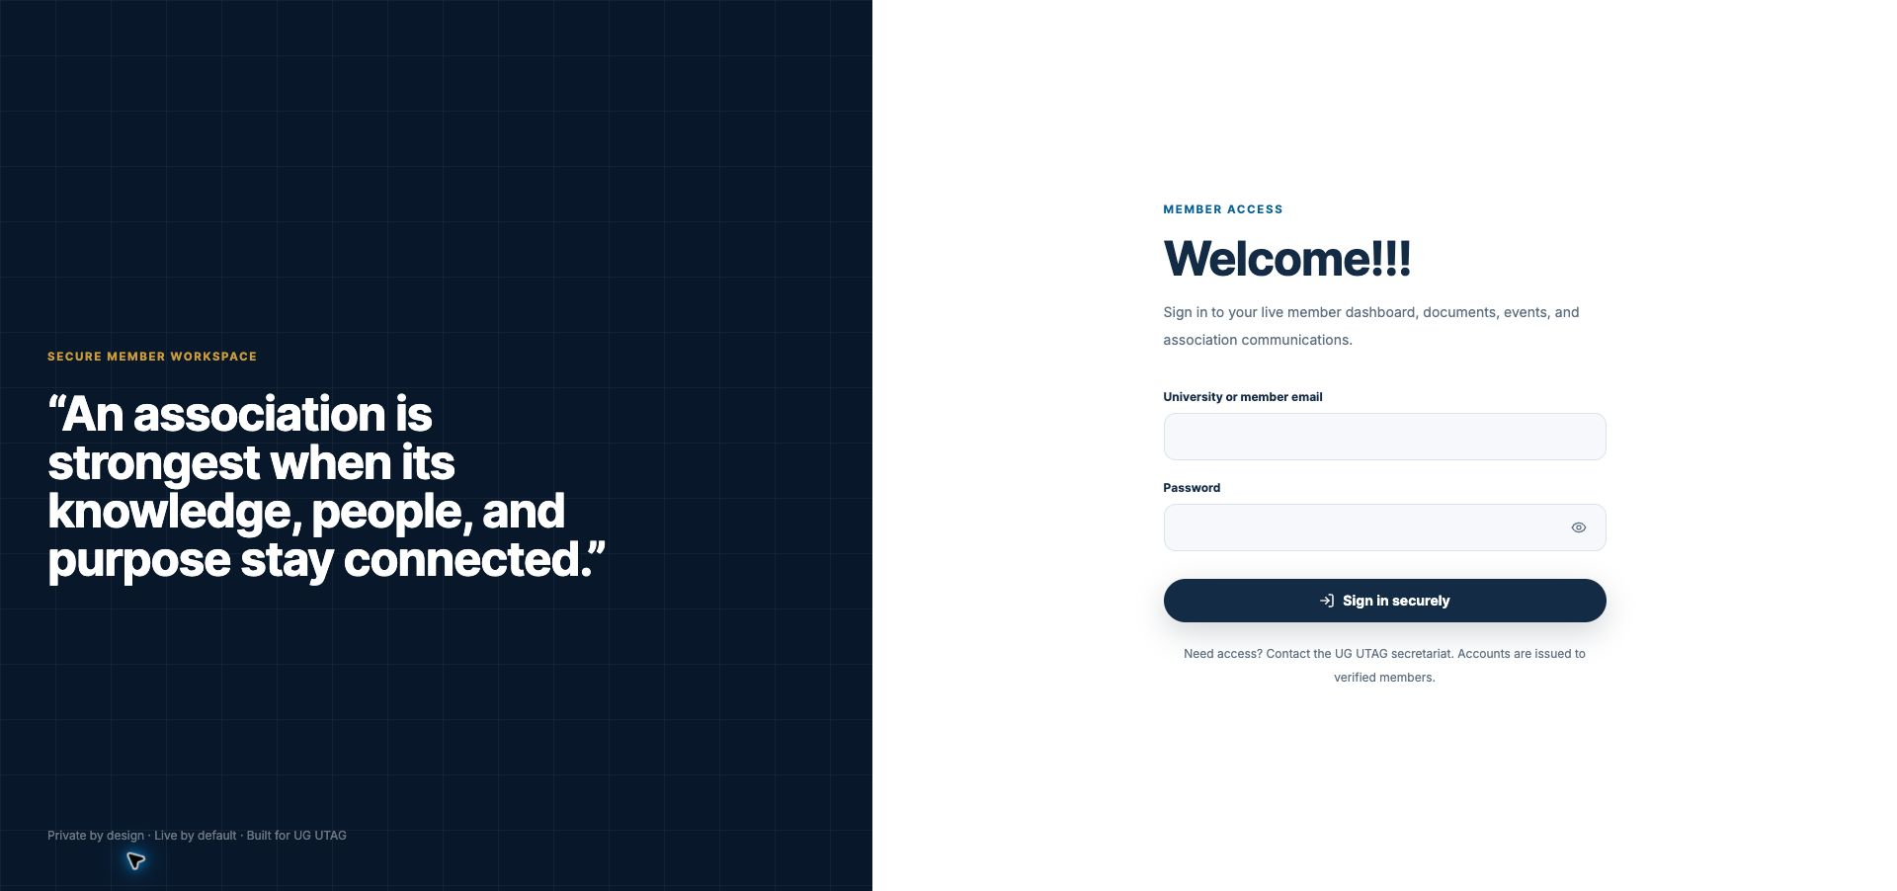
Figure 15. After Sign out, the portal returns to the member sign-in page.

SUPPORT

Troubleshooting and safe assistance
Use the checks below before requesting help.
ISSUE | WHAT TO DO
Cannot sign in | Check the email for typing errors, confirm that your account has been issued, and re-enter the password carefully. Use the eye icon only in a private setting.
Temporary password | If your account uses your Staff ID as a temporary password, sign in and replace it with a personal password as soon as prompted or from Profile → Security.
Password update fails | Confirm the current password, make the two new-password entries identical, and use at least 8 characters with uppercase and lowercase letters and a number.
Page looks out of date | Refresh once. If the problem continues, sign out, close the browser tab, and sign in again.
No event, file, or message appears | The item may not be published or visible to your membership group. Check the filters, then contact the secretariat if you still expect access.
Need assistance | Contact the UG UTAG secretariat and include your member email, the screen name, the time of the issue, the exact error message, and a screenshot. Never send your password.
WHEN REQUESTING HELP Send the member email, the screen or section name, the time of the problem, the exact error text, and a screenshot. Crop or cover private information first. Never send a password or one-time code.

UG UTAG secretariat
Email: utagoffice@ug.edu.gh Telephone: +233 (0) 24 427 7275
Portal: Open the UG UTAG member portal

